AP Calc AB Name: _______________

______________ _____________

WS Assessment

Target 20:

Slope field

**I can:**

* Estimate solutions to differential equations using slope field
* Interpret the meaning of a differential equation and its variables in context

Unit 7: Differential Equations

HW Target 20 Unit 7 Progress Check FRQ

Definition: A slope field for the first-order differential equation dy/dx = f(x,y) is a plot of short line segments with slopes f(x, y) at a lattice of points (x, y) in the plane.

Draw a slope field for y ' = y – x. Fill in the table, and graph the slope field (remember y ' is ?)

|  |  |  |  |  |  |  |  |  |  |  |  |  |  |  |  |  |  |  |  |  |  |  |  |  |  |  |  |  |
| --- | --- | --- | --- | --- | --- | --- | --- | --- | --- | --- | --- | --- | --- | --- | --- | --- | --- | --- | --- | --- | --- | --- | --- | --- | --- | --- | --- | --- |
| x | y | y ' | Use Euler's method (i.e. solve the differentiate equation using small increase) for diff equation y' = y – x to approximate f(0.3) =? Given the initial f(0) = -1 and step size = 0.1  Solution: Since dy/dx = y – x → dy = (y – x) dx (replace y ' = y – x )  dy = (y ')dx or Δy = (y')(Δx)  Given Δx → find y' and Δy then move to next step   |  |  |  |  |  | | --- | --- | --- | --- | --- | | (x, y) | y' = y – x | Δx | Δy = (y')(Δx) | (x + Δx, y +Δy) | | (0, -1) | -1 – 0 = -1 | 0.1 | (-1)(0.1)= -.1 | (0.1, -1.1) | | (0.1, -1.1) | ? |  |  |  | |  |  |  |  |  | |  |  |  |  |  | |
| 0 | -3 |  |
| 0 | -2 |  |
| 0 | -1 |  |
| 0 | 0 |  |
| 0 | 1 |  |
| 0 | 2 |  |
| 1 | -3 |  |
| 1 | -2 |  |
| 1 | -1 |  |
| 1 | 0 |  |
| 1 | 1 |  |
| 1 | 2 |  |
| -1 | -3 |  |
| -1 | -2 |  |
| -1 | -1 |  |
| -1 | 0 |  |
| -1 | 1 |  |
| -1 | 2 |  |
| -2 | -3 |  |
| -2 | -2 |  |
| -2 | -1 |  |
| -2 | 0 |  |
| -2 | 1 |  |
| -2 | 2 |  |
| 2 | -3 |  |
| 2 | -2 |  |
| 2 | -1 |  |
| 2 | 0 |  |
| 2 | 1 |  |
| 2 | 2 |  |

Draw a slope field for y ' = x2 Fill in the table, and graph the slope field

|  |  |  |  |  |  |  |  |  |  |  |  |  |  |  |  |  |  |  |  |  |  |  |  |  |  |  |  |  |
| --- | --- | --- | --- | --- | --- | --- | --- | --- | --- | --- | --- | --- | --- | --- | --- | --- | --- | --- | --- | --- | --- | --- | --- | --- | --- | --- | --- | --- |
| x | y | y ' | Use Euler's method to approximate f(2) =?  Given the initial f(1) = 1 and step size = 0.2  Hint dy/dx = x2 → dy = x2dx or dy = (y ')dx or Δy = (y')(Δx)   |  |  |  |  |  | | --- | --- | --- | --- | --- | | (x, y) | y' = ?_____ | Δx | Δy = ?______ | (x + Δx, y +Δy) | |  |  |  |  |  | |  |  |  |  |  | |  |  |  |  |  | |  |  |  |  |  | |
| 0 | -3 |  |
| 0 | -2 |  |
| 0 | -1 |  |
| 0 | 0 |  |
| 0 | 1 |  |
| 0 | 2 |  |
| 1 | -3 |  |
| 1 | -2 |  |
| 1 | -1 |  |
| 1 | 0 |  |
| 1 | 1 |  |
| 1 | 2 |  |
| -1 | -3 |  |
| -1 | -2 |  |
| -1 | -1 |  |
| -1 | 0 |  |
| -1 | 1 |  |
| -1 | 2 |  |
| -2 | -3 |  |
| -2 | -2 |  |
| -2 | -1 |  |
| -2 | 0 |  |
| -2 | 1 |  |
| -2 | 2 |  |
| 2 | -3 |  |
| 2 | -2 |  |
| 2 | -1 |  |
| 2 | 0 |  |
| 2 | 1 |  |
| 2 | 2 |  |

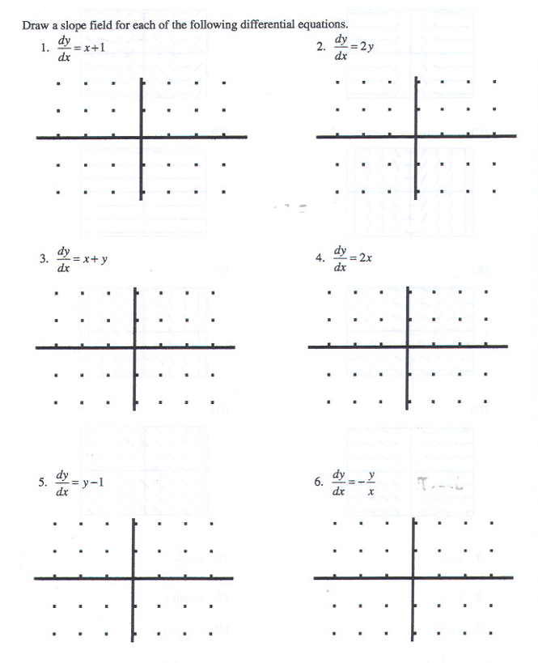

Find the derivative of the following functions then match with its slope fields as shown

y = - cos(x) + 1

|  |  |
| --- | --- |
|  |  |
|  |  |

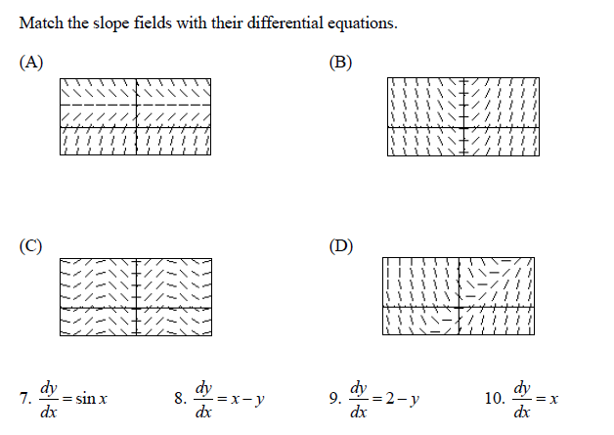

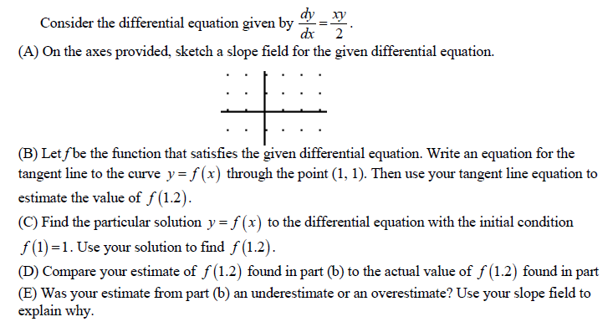

**Assessment**

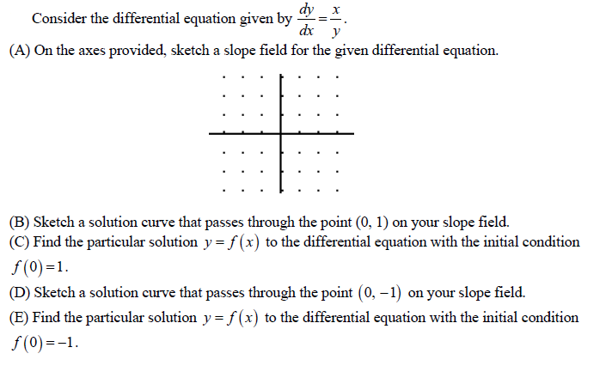



A kitten weighs 85 grams at birth. During the first four weeks after the kitten’s birth, its

weight in grams is given by the function that satisfies the differential equation $\frac{dW}{dt}=kW$, where t is measured in days and k is some positive constant. Write its weight function W(t)

During optimal conditions, the rate of change of the population of a certain organism is proportional to the population at time t , in hours. At time t = 0 hours, the population is 300. At time t = 24 hours, the population is 1000. At what time is the population 500 ?

Extreme heat applied to a colony of microorganisms causes the size P of the colony,

measured in grams, to decrease according to the exponential decay model $\frac{dP}{dt}=-0.4P$,

where the time t is measured in hours. The size Q of a second colony of microorganisms,

also measured in grams, decreases at the constant rate of 1 gram per hour according to

the linear model $\frac{dQ}{dt}=-1$. If at time t = 0 the first colony has size P(0) = 2and the

second colony has size Q(0) = 3, at what time will both colonies have the same size?